**Load Device Shape**

The config file is a conglomeration of various sections.For the Recipe editor the focus is on few of the fields. The data modelling is done for the config file.The modelling shall be done in the JSON format.

The JSON data shall consist the Action Group,Actions,Operator,Boolean and Criteria. Below is the data format

**API Definition**

|  |  |  |  |
| --- | --- | --- | --- |
| **API** | **Description** | **Definition** | **Class Name** |
| getDeviceShapeObjects | Api shall be used for fetching the configuration file objects. | JSON object of data | DeviceShape |

**Scope**

Predefined JSON data object for valve control and open action.

**Sample JSON**

|  |
| --- |
| {                  ActionGroup: [                                  'ValveControl',                                  'Pump'                  ],                                  ValveControl:                                    [{                                                  'ActionDescriptionOpen': 'XV201 Inlet S1.1 Open',                                                  "TAG": "",                                                  "RANGE LO": "",                                                  "RANGE-HIGH": "",                                                  "EGU": "",                                                  "Action": "",                                                  "ActionValue": "1",                                                 "Named Actionlist":"",                                                  "Analog Action Description": "",                                                  "Analog Action Code": "",                                                  "Phase": "",                                                  "Type": "",                                                  "logging PLC Address": ""                                  },                                  {                                                  'ActionDescription': 'XV201 Inlet S1.1 Close',                                                  "TAG": "",                                                  "RANGE LO": "",                                                  "RANGE-HIGH": "",                                                  "EGU": "",                                                  "Action": "",                                                  "ActionValue": "0",                                                  "Named Actionlist": "",                                                  "Analog Action Description": "",                                                  "Analog Action Code": "",                                                  "Phase": "",                                                  "Type": "",                                                  "logging PLC Address": ""                                  }                  ],                  "Criteria": [{                                                  "CriteriaDescription": "Total Time",                                                  "TAG": "",                                                  "RANGE-LO": "0",                                                  "RANGE-HIGH": "999999",                                                  "EGU": "sec",                                                  "Criteria Code": "1100001",                                                  "Criteria Value": "",                                                  "Scaling": "",                                                  "Phase": "",                                                  "Internal Use": "",                                                  "OperationStatus": "Enabled",                                  },                                  {                                                  "CriteriaDescription": "FLC001 Pump1 Control Stable",                                                  "TAG": "",                                                  "RANGE-LO": "",                                                  "RANGE-HIGH": "",                                                  "EGU": "",                                                  "Criteria Code": "500118",                                                  "Criteria Value": "1",                                                  "Scaling": "",                                                  "Phase": "",                                                  "Internal Use": "",                                                  "OperationStatus": "Disabled"                                  }                  ],                  "Operation": ["None", "=", ">=", "<="],                  Bool: ['OR', 'AND'],                  Val:['1'],                  Label: ['1', '2', '3', '4','5']  } |

**Sequence Diagram**

Below is the sequence Diagram for the same

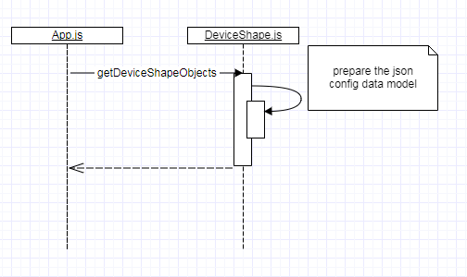

**Recipe Editor:**

The web based app with index.html the launcher page. The page has the root container on which the ReactDOM shall render other components.

**The Block diagram for DOM**

Root

Components

App

**Root:**

This block is a rendering block. The Root block shall be a single JavaScript file which shall load the entire DOM. The input for this block shall be from the App.js.

**App:**

The App block shall be the JavaScript file which shall be the outer container for the entire page. The input for this block shall be from the components.

**Components:**

The component shall be conglomeration various components JavaScript files which shall have all the JSX component within each files. The call-backs for various components shall be available within these individual component files.

Components files implemented are

RecipeTable.js

**JS Definition**

|  |  |  |  |
| --- | --- | --- | --- |
| **JS** | **Description** | **Definition** | **Class Name** |
| RecipeTable | JS shall be used for populating the table and modal components. | Component table | RecipeTable,Modal |

Dropdownlist.js

**JS Definition**

|  |  |  |  |
| --- | --- | --- | --- |
| **JS** | **Description** | **Definition** | **Class Name** |
| Dropdownlist | JS shall be used for dropdown of the component | Component table | Dropdownlabel |

The styling for these components are also implemented. Below are the style sheets

Stylerecipes.css

CriteriaDialog.css

CommentDialog.css

Sequence Diagram

ReactDOM.render() </RecipeTable> </Dropdownlabel>

Dropdownlist.js

Recipe_Table.js

App.js

Index.js